Simple Query SQL Bagian 2

select category_id, count(category_id) as total

from obat

where stok >= 10

group by category_id

order by stok;

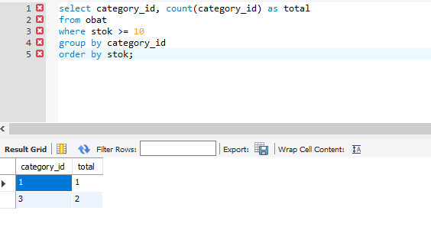

select category_id, count(category_id) as total

from obat

where stok >= 10

group by category_id

order by stok desc;

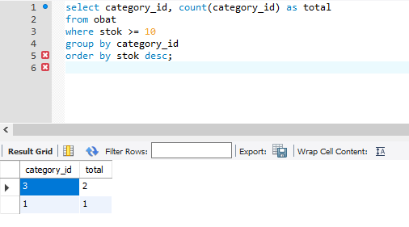

select *

from obat

where harga > 15000

and stok > 5

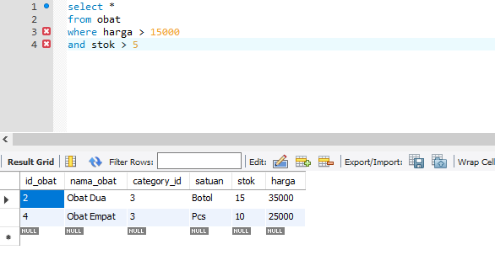

select id_transaksi, jmlh_obat, sum(harga)

from penjualan_detail

group by id_transaksi

having jmlh_obat > 2

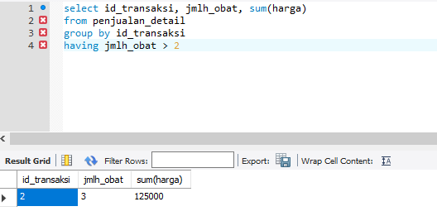

select id_transaksi, jmlh_obat, count(id_tx_detail) as total_row

from penjualan_detail

group by id_transaksi

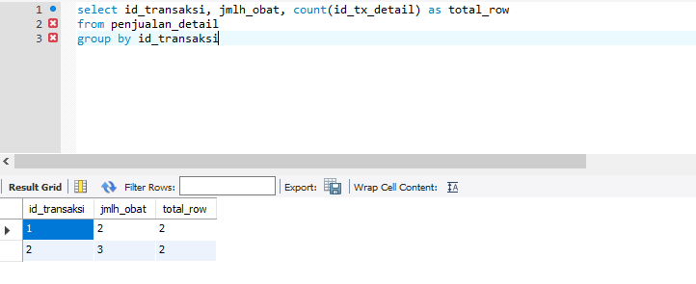

select category_id, sum(stok) as total

from obat

group by category_id

having total > 5

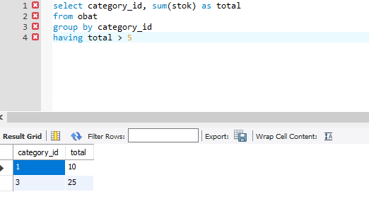

select *

from penjualan

where year(tgl_transaksi) = 2022

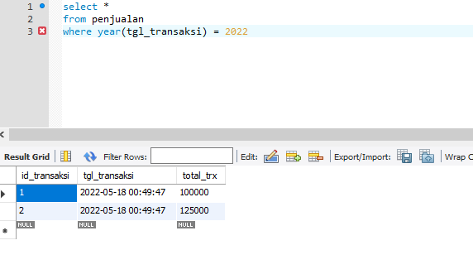

select *

from penjualan

where year(tgl_transaksi) = 2022

and total_trx > 100000

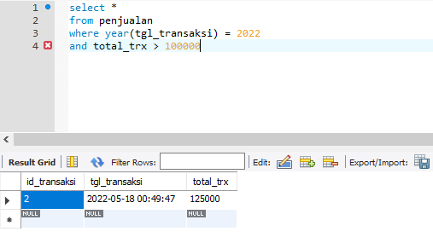

select *

from penjualan

where year(tgl_transaksi) = 2022

order by total_trx desc

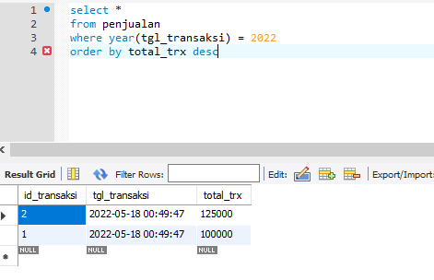

select category_id, sum(stok) as total

from obat

group by category_id

having total > 5

order by total desc

